Name : HIMANSI RUDRA

ROLL NO. : 422156

SEC : A

LAB WEEK 3

Write shell script for searching for various patterns using grep, pr, head, tail, cut, paste, sort, uniq, and tr.

GREP COMMAND:

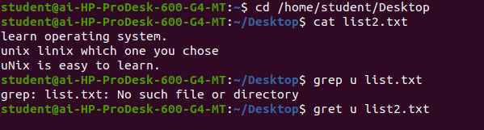

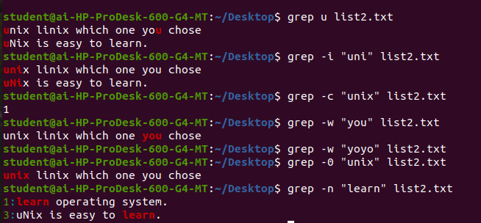

PR COMMAND:

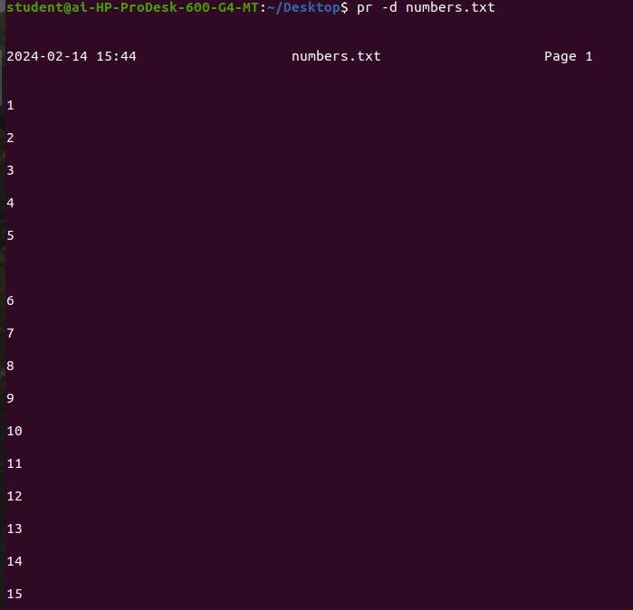

HEAD COMMAND: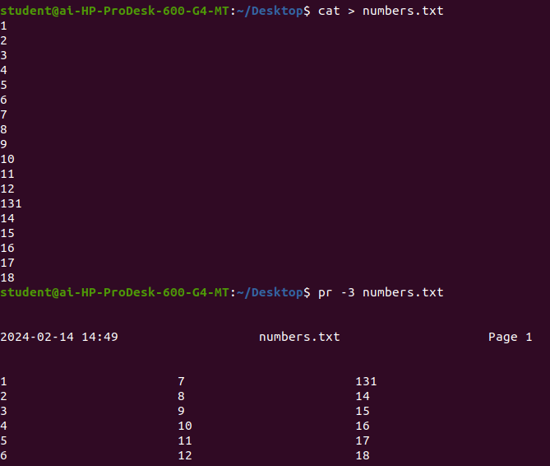

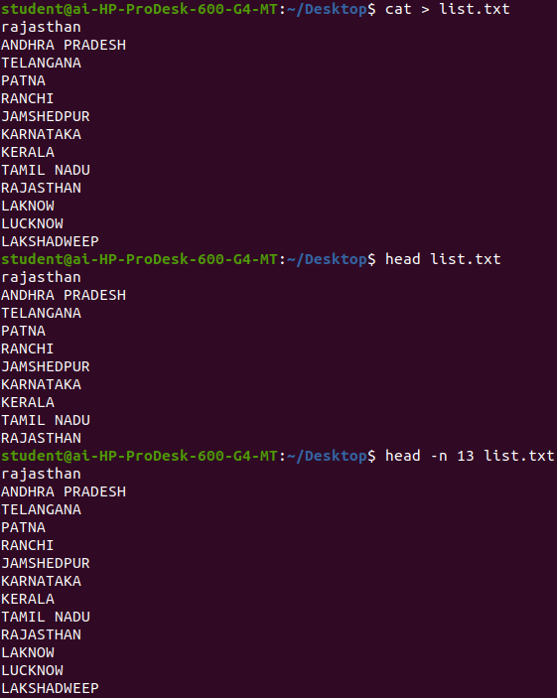

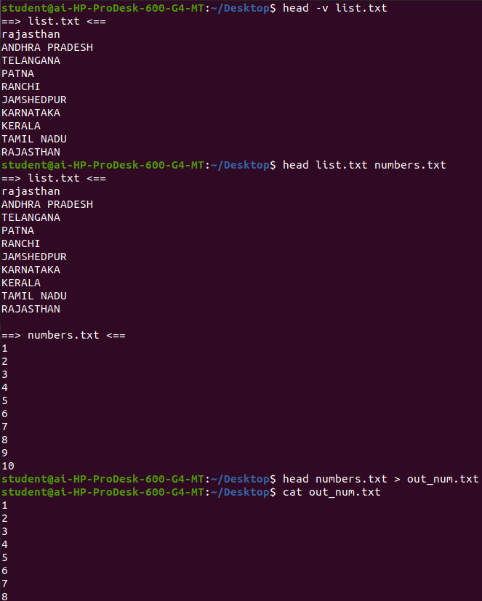

TAIL COMMAND:

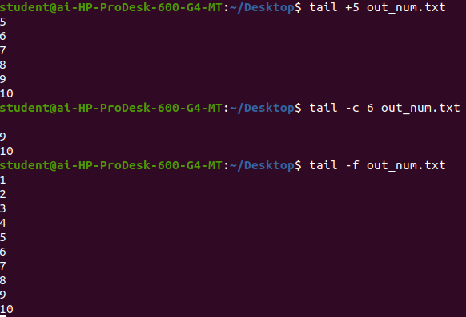

CUT COMMAND:

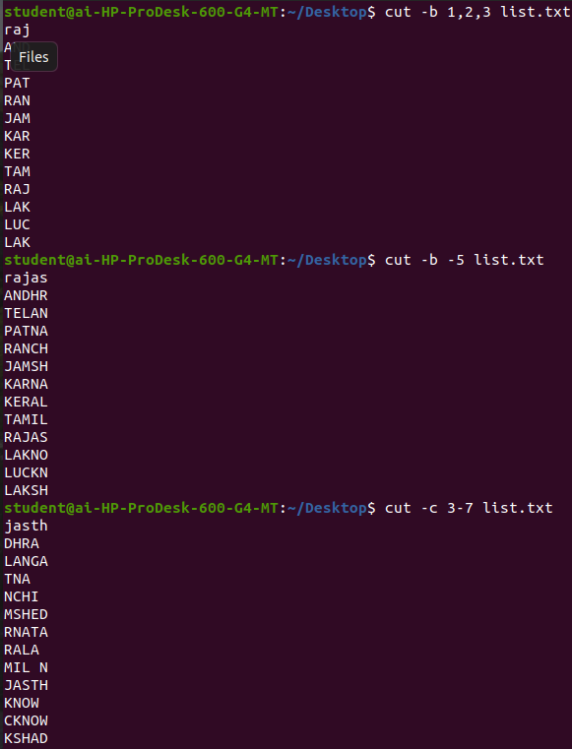

PASTE COMMAND:

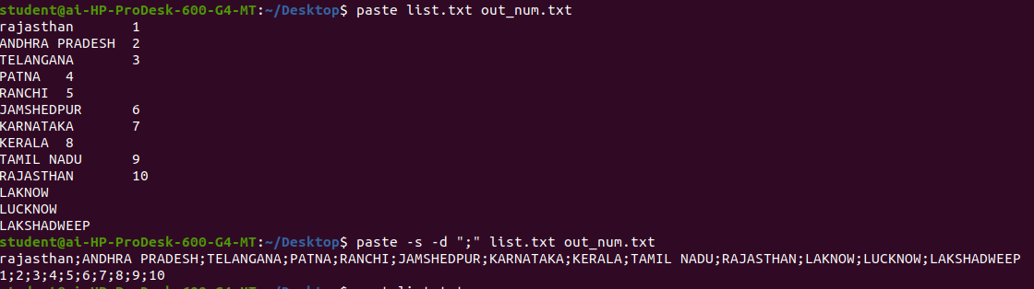

SORT COMMAND:

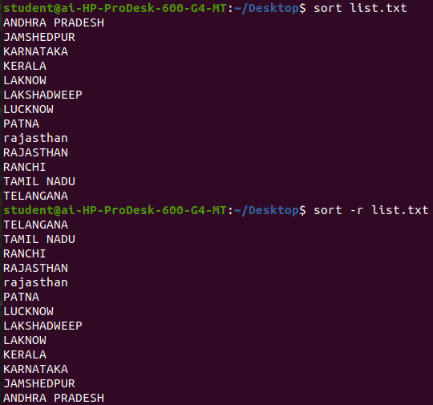

UNIQ COMMAND:

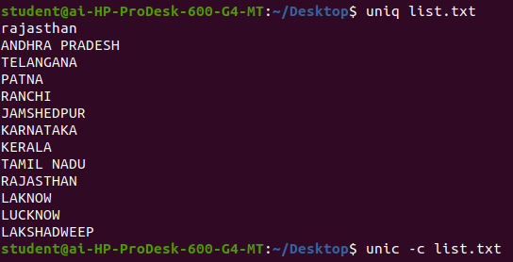

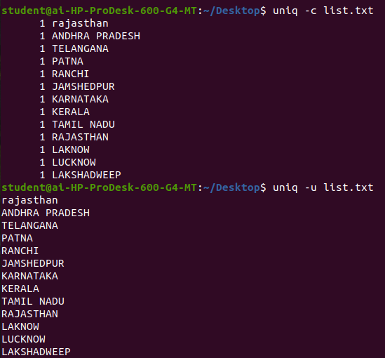

TR COMMAND:

